**National University of Computer & Emerging Sciences**

**Karachi Campus**



**DATABASE MANAGEMENT SYSTEM**

**COURSE CODE: CS-2005**

**DEPARTMENT: BS(CS)**

**SOCIETY CLUB PORTAL(REPORT)**

**Group Members:**

**19K-0289 Ibrahim Ali**

**19K-1443 Ibrahim Ali Asghar**

* **Problem Statement**

Society Club portal is a web-based application that will notify the students about the events and activities to be conducted in near future.

This management system will help societies of a university to manage their programme easily. This system will have three interfaces: Admin, Society, and Student interface.

* **Entity Relationship Diagram**

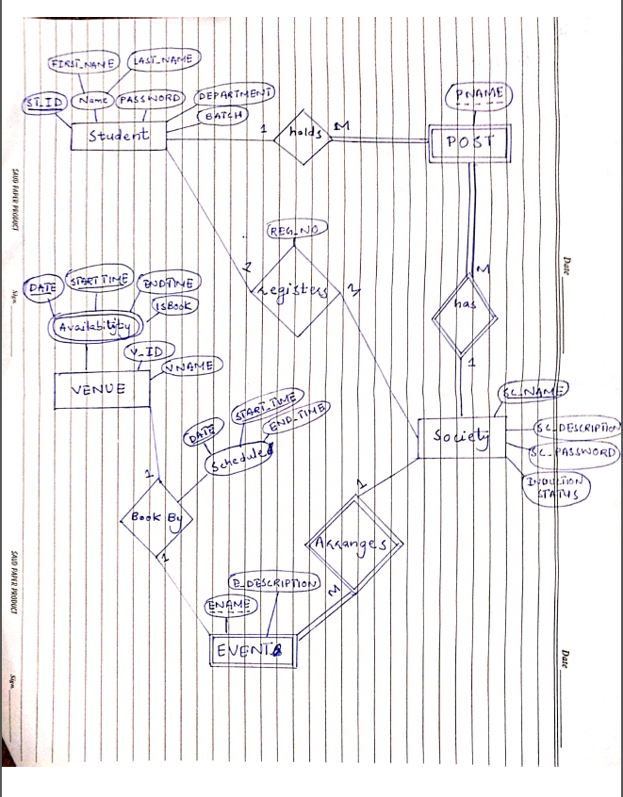

**Brief of Entity Relationship Diagram**

Strong Entity Types:

* Society
* Student
* Venue

Weak Entity Types:

Events

Post

**Relationships in ERD**

**Society_Post:**

Society has posts.

Post is dependent upon society because there can be same post in different society.

1 society can have MANY posts.

**Society_Event:**

Society arranges events.

Event is dependent upon society because there can be same event arrange by other society.

1 society can have MANY events.

**Society_Student:**

Student registers for Inductions.

Partial dependency from both sides

1 student can register for induction in MANY societies.

**Student_Post:**

Student hold posts.

1 student can have 1 post from a society.

**Venue_Events:**

Venues are booked for events which includes scheduling.

1 event can book one venue.

* **Relational Schema**

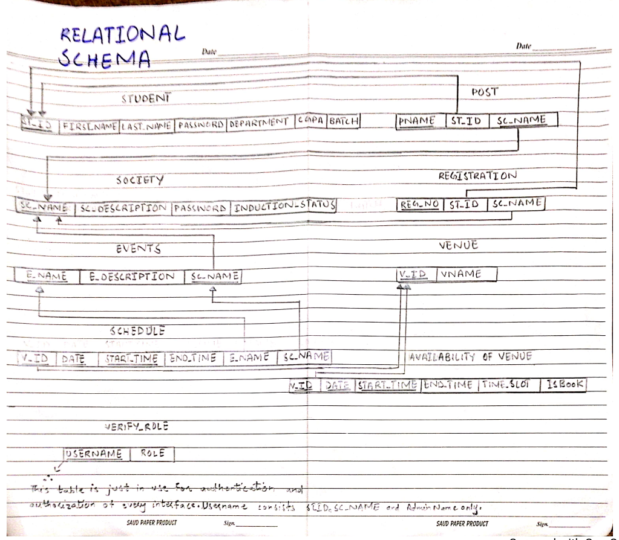

* **Relational Schema Up To 3NF**

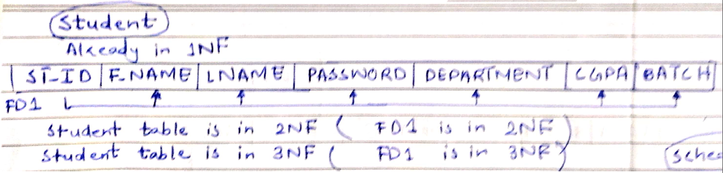

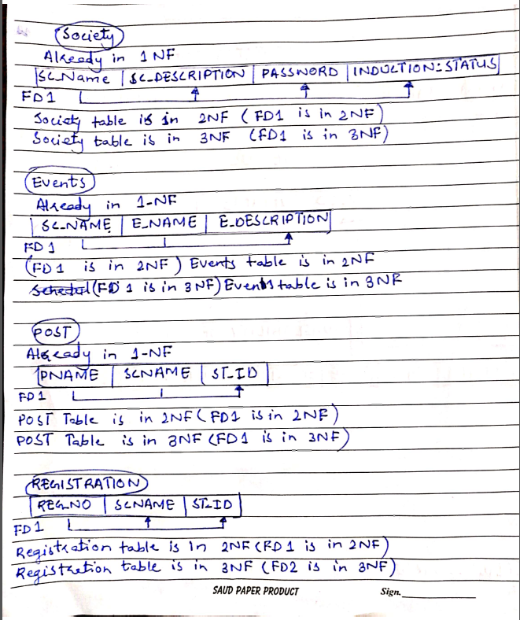

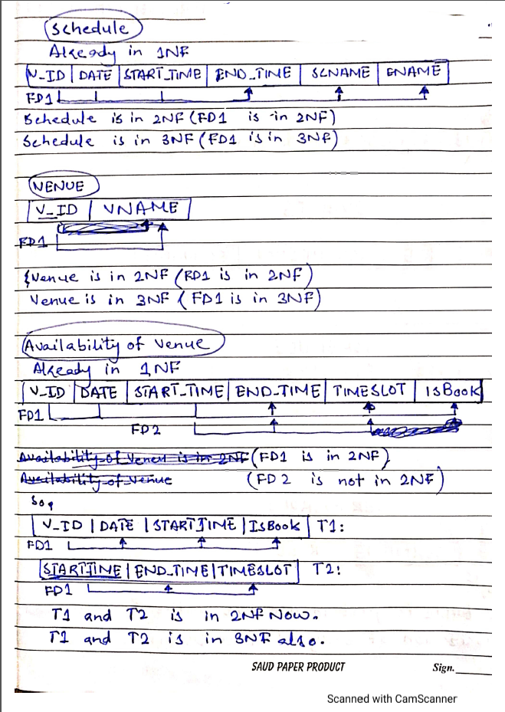

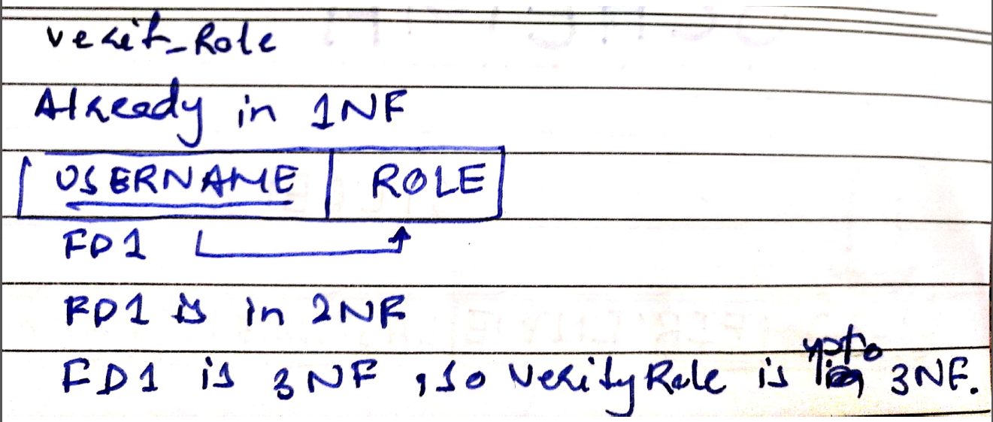

# ARCHITECTURE DESIGN

Pull data via getters

Pull data via getters

Updates data via setters and event handlers

CONTROLLER

LoginController

AdminController

StudentController

SocietyController

MODEL

Availability_Of_VenueRepository: SocietyController

EventsRepository: SocietyController

PostRepository: SocietyController, StudentController

RegistrationRepository: SocietyController, StudentController

ScheduleRepository: SocietyController, StudentController

SOC_REG_IND_POSTRepository: StudentController

SocietyRepository: AdminController, LoginController, SocietyController, StudentController

StudentRepository: AdminController LoginController, StudentController

VenueRepository: SocietyController, StudentController

Verify_RoleRepository

VIEW

LOGIN:

Index

ADMIN:

AddSociety, AddStudent, Home, Societies_Data, Students_Data, Update_Society, Update_Student

SOCIETY:

Add_new_post, Add_Student_on_post, AddEvent, Change_Student_on_post, Events, Home, Inductions, Schedule, Update_Description

STUDENT:

Home, View_All_Events, View_Events, View_Hierarchy, View_Society

Initiates

Modifies

Sets data via setters

* **Snapshots of Operations**

1. LOGIN PAGE

Through this interface different types of users can login to the portal.

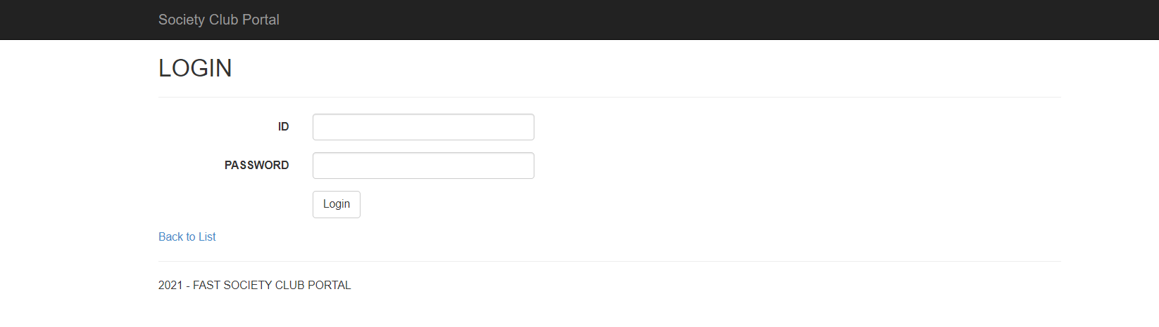

1. ADMIN
   1. HOME

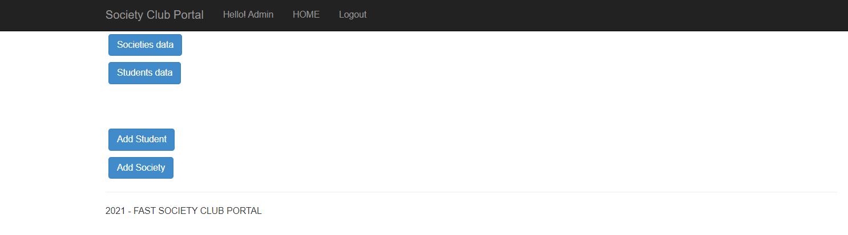

* 1. VIEW ALL SOCITIES’ DATA

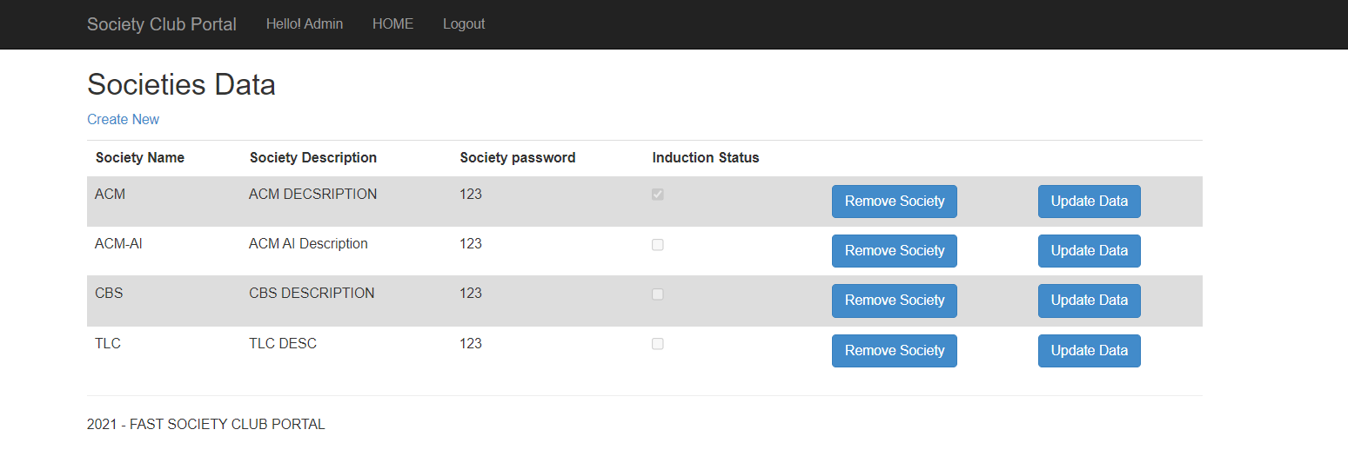Admin can view, update, and remove societies data through this view.

* 1. UPDATE SOCIETY DATA

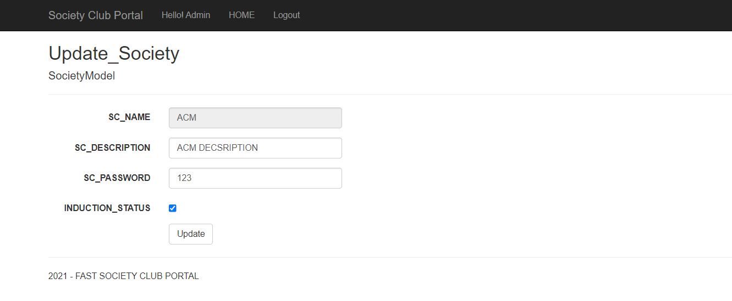Admin can update society data through this form.

* 1. VIEW ALL STUDENTS’ DATA

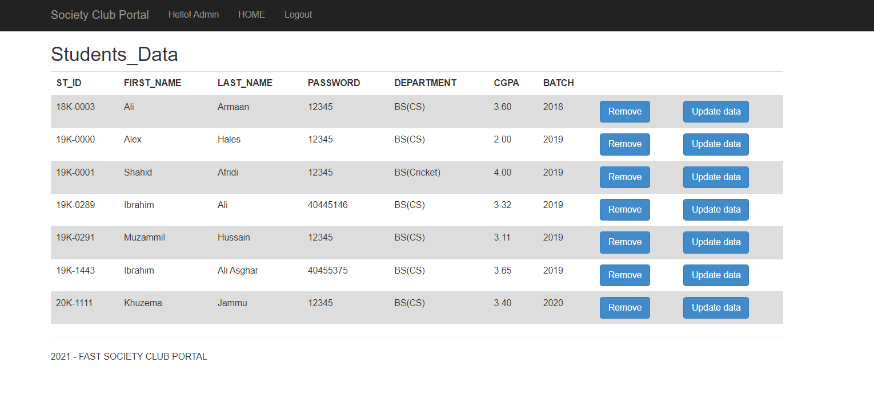Admin can view, update, and remove students’ data through this view.

* 1. UPDATE STUDENT DATA

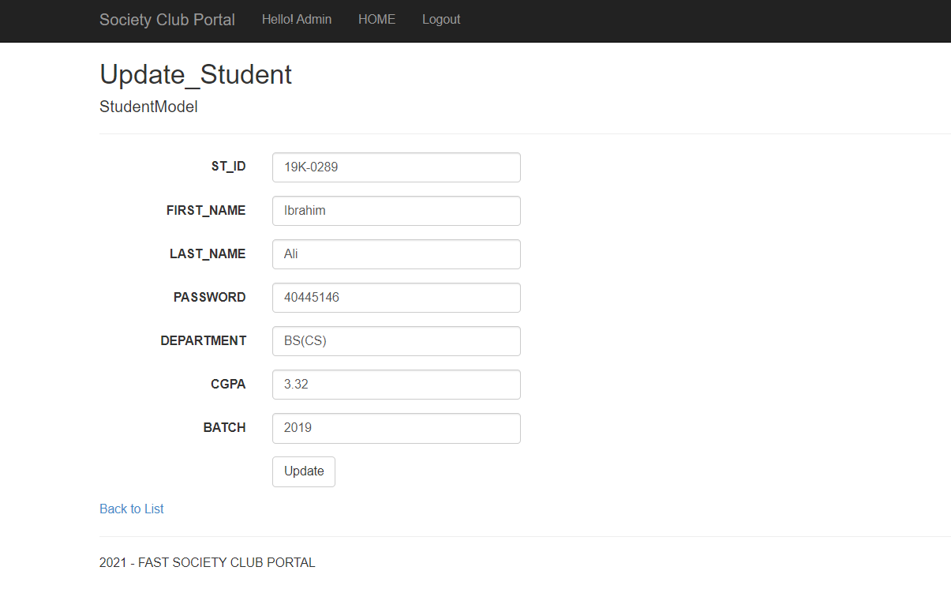Admin can update student’s data through this form.

* 1. ADD NEW STUDENT

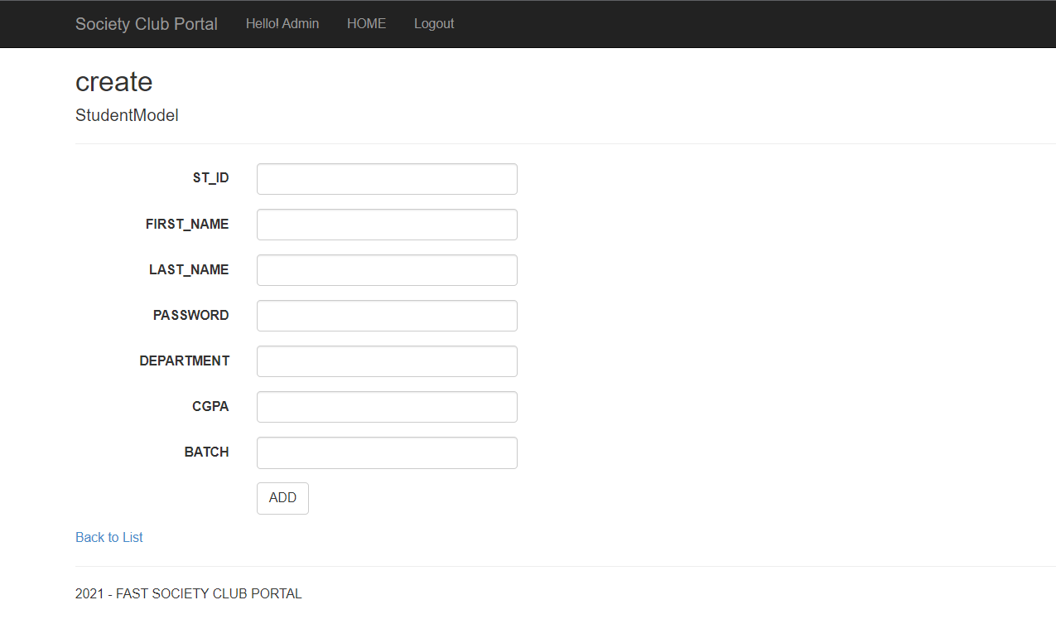Admin can add new student through this form.

* 1. ADD NEW SOCIETY

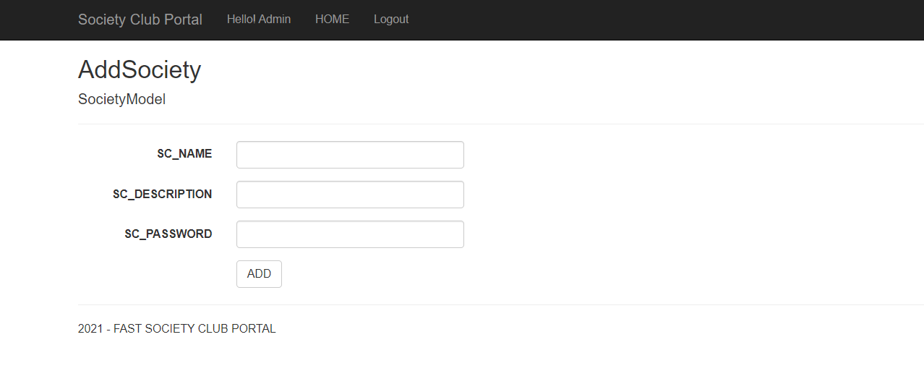Admin can add new student through this form.

1. SOCIETY
   1. 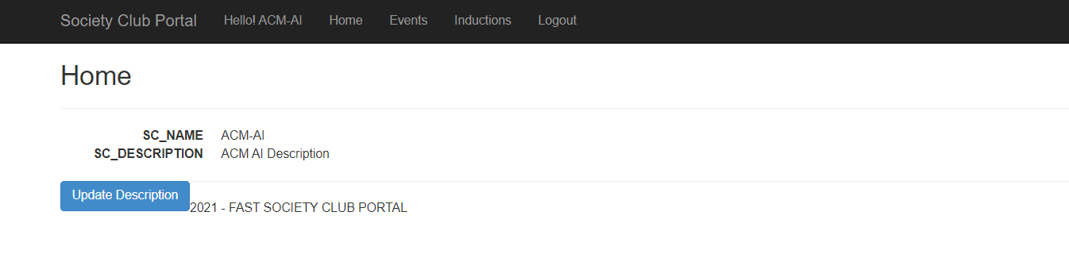HOME
   2. UPDATE DESCRIPTION

Society can update its own through this form.

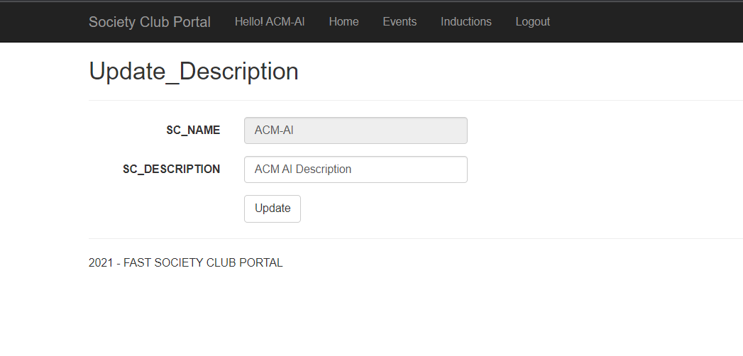

* 1. VIEW ALL SCHEDULED/UNSCHEDULED EVENTS

Society can view all its events either scheduled or not on this page.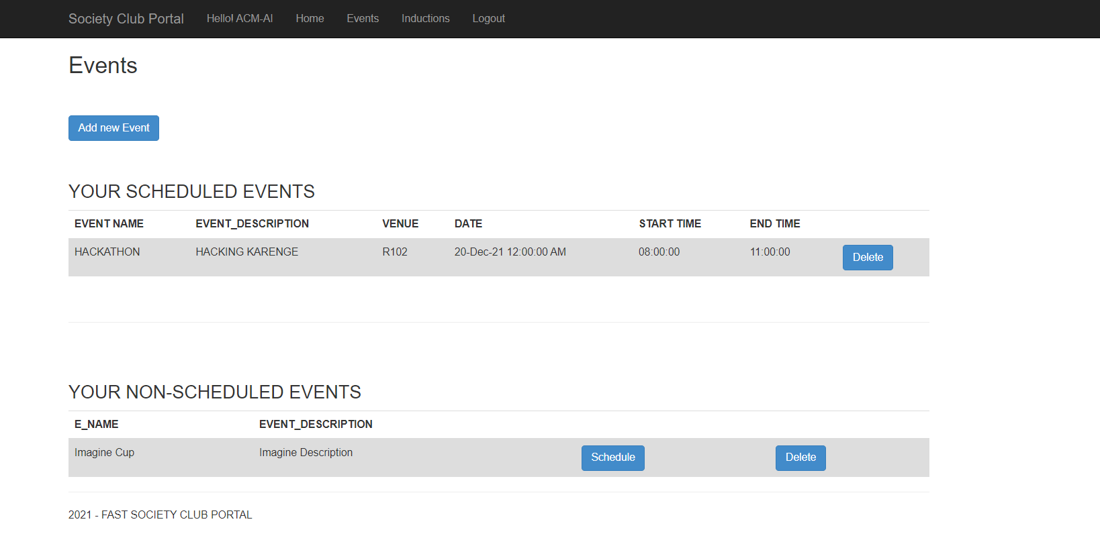

* 1. ADD NEW EVENT

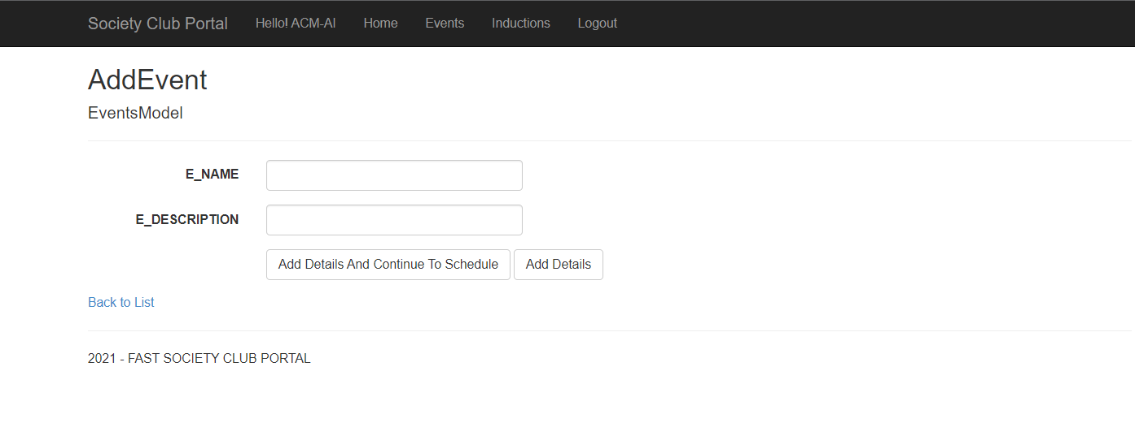Society can add new event through this form.

* 1. SCHEDULE AN EVENT

Society can schedule its event through this form.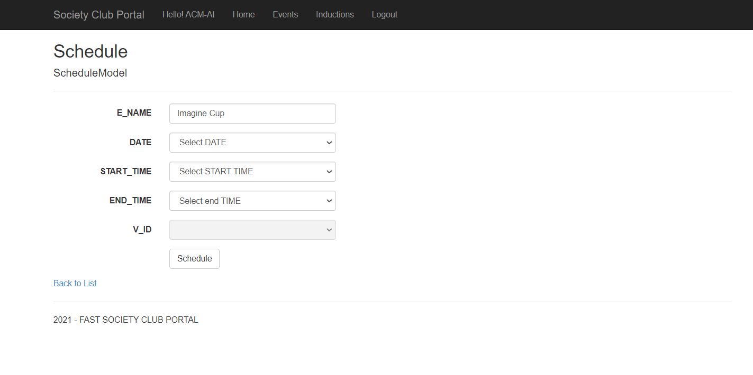

* 1. INDUCTIONS

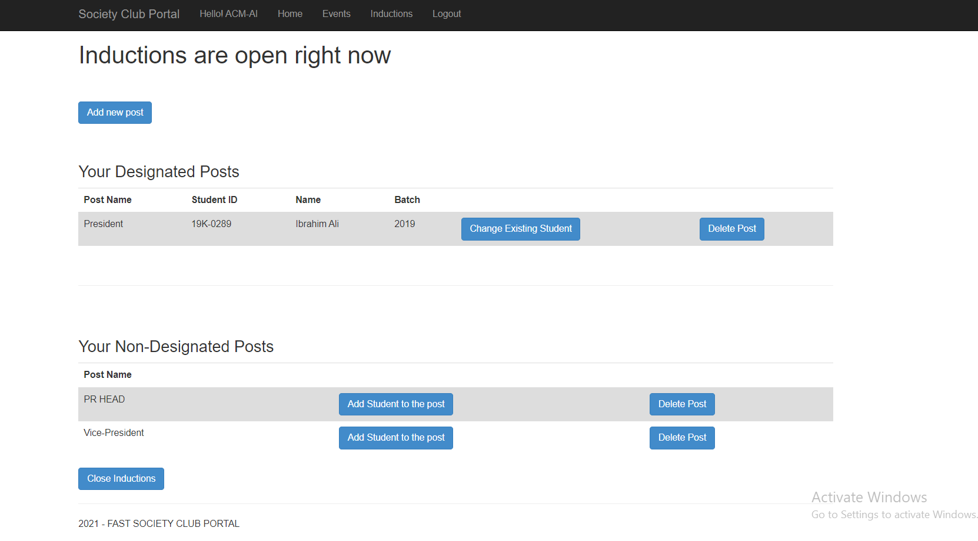Society can open/close inductions, add new post, delete post, select/swap students for posts through this page.

* 1. ADD NEW POST

Society can add new posts through this form.

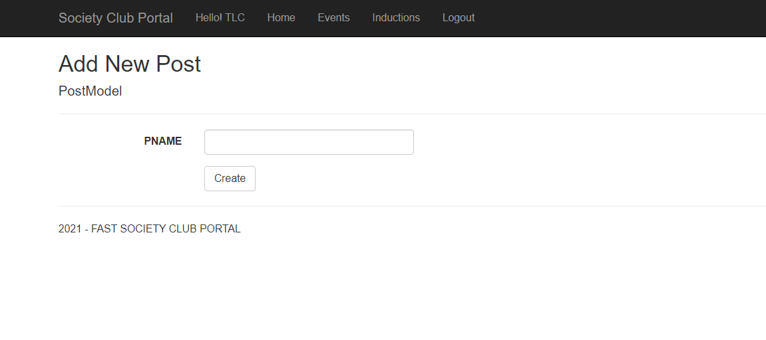

* 1. ADD STUDENT ON POST

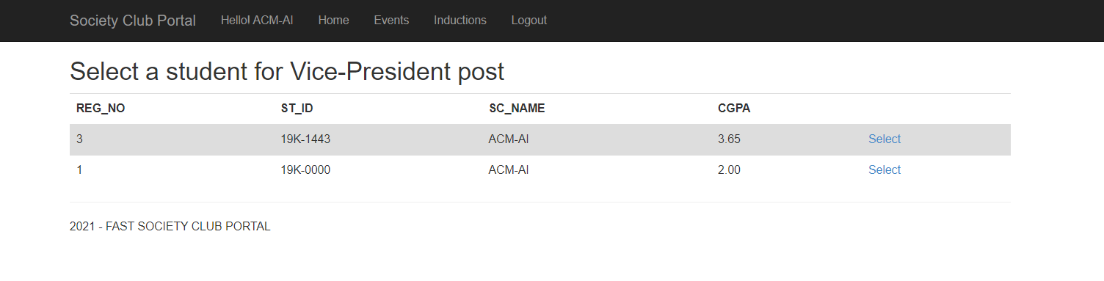Society can add students on posts through this form.

1. STUDENT
   1. 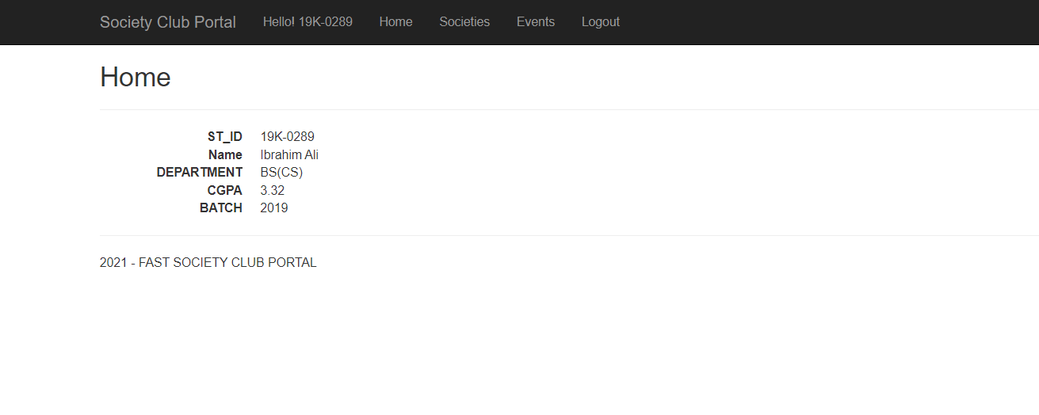HOME
   2. VIEW ALL SOCIETIES

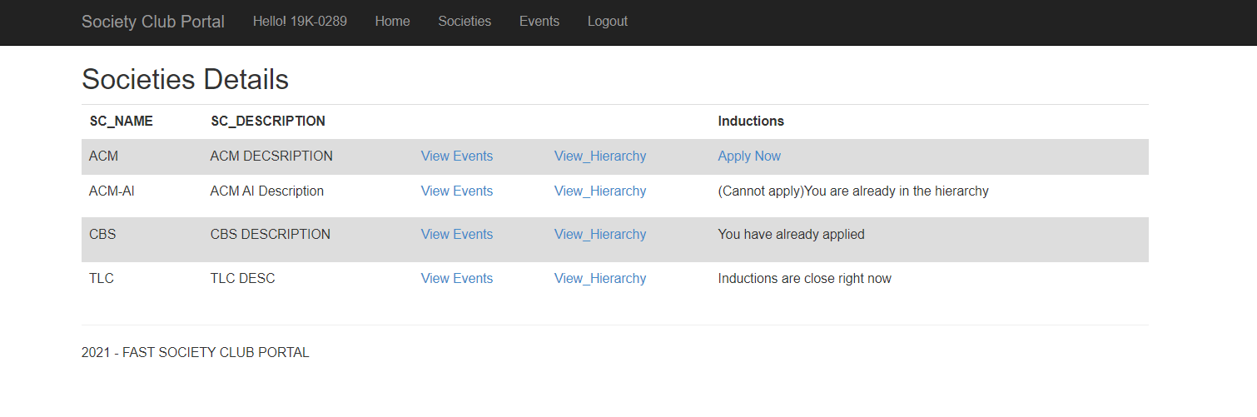Student can view all the societies, register for inductions, view hierarchy of each society, view scheduled events of each society individually through this view.

* 1. 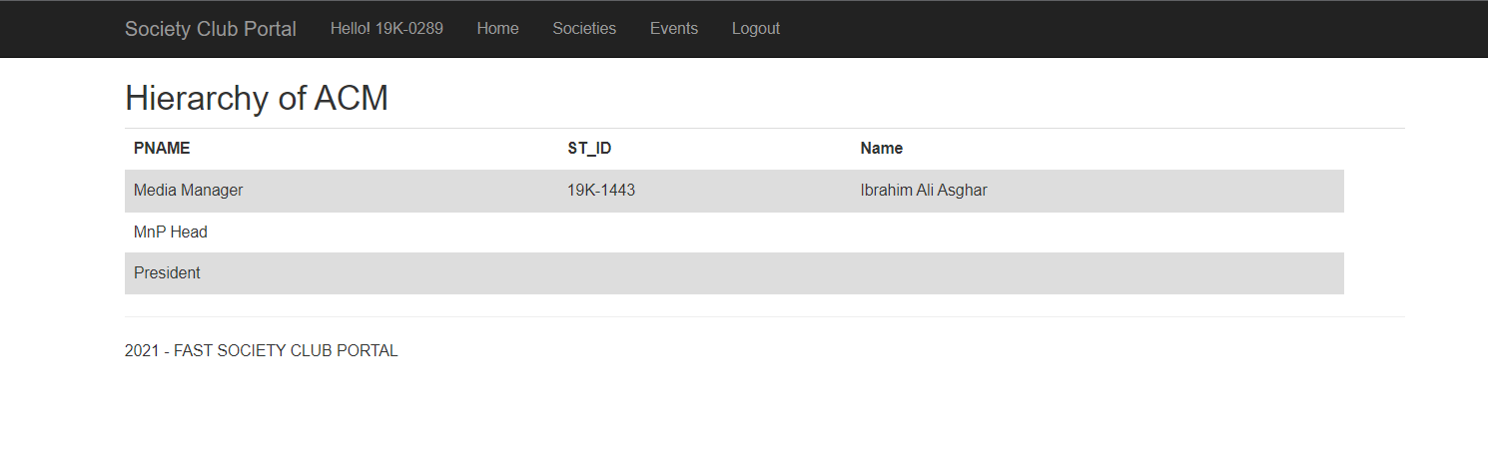VIEW HIERARCHY
  2. 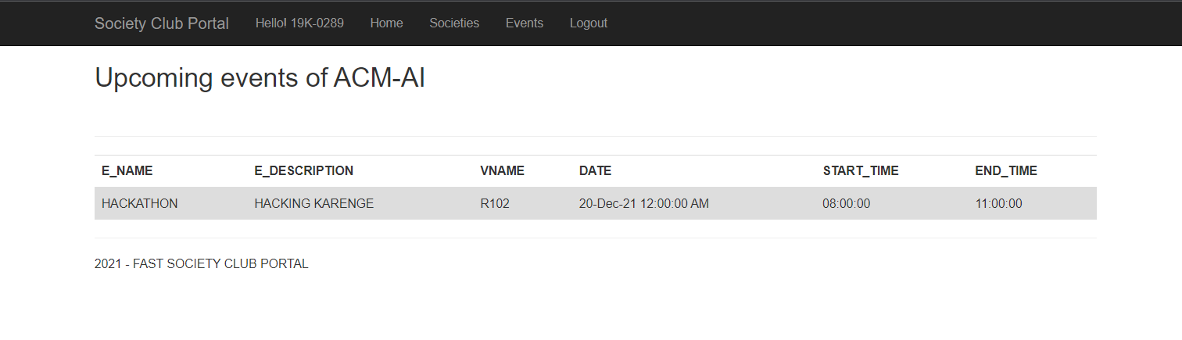 VIEW SCHEDULED EVENTS W.R.T SOCIETY
  3. 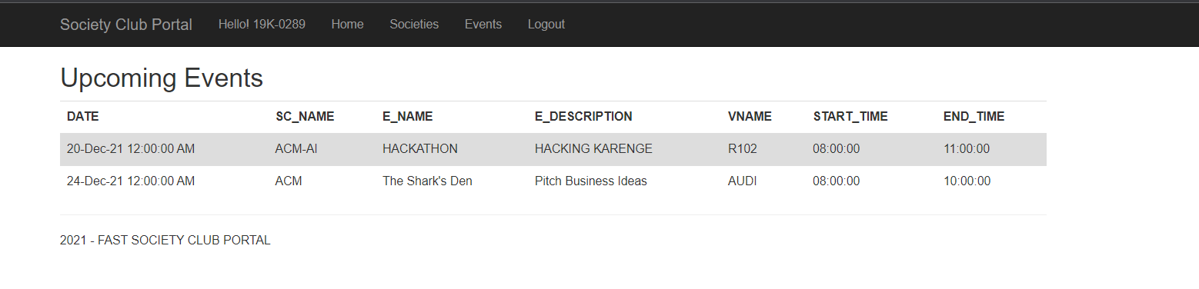VIEW ALL SCHEDULED EVENTS
* **All Features Description**

1. Every user has to login to the portal first.
2. Students will be able to see the description of all societies.
3. Students will be notified about every event to be held by any of the society.
4. Students can apply for the inductions of societies.
5. Students can view hierarchy of all the societies
6. Society can add/delete events
7. Society can schedule their events.
8. Society will notify the students about inductions
9. Society can view the registered students on the basis of their CGPAs and can select them for a particular post
10. Society can view the scheduled/non-scheduled events of their society.
11. Admin can add/update/delete students and societies information into the portal.